

**FPT ACADEMY INTERNATIONAL**

**FPT - APTECH COMPUTER EDUCATION**

Camping & Equipment Rental System

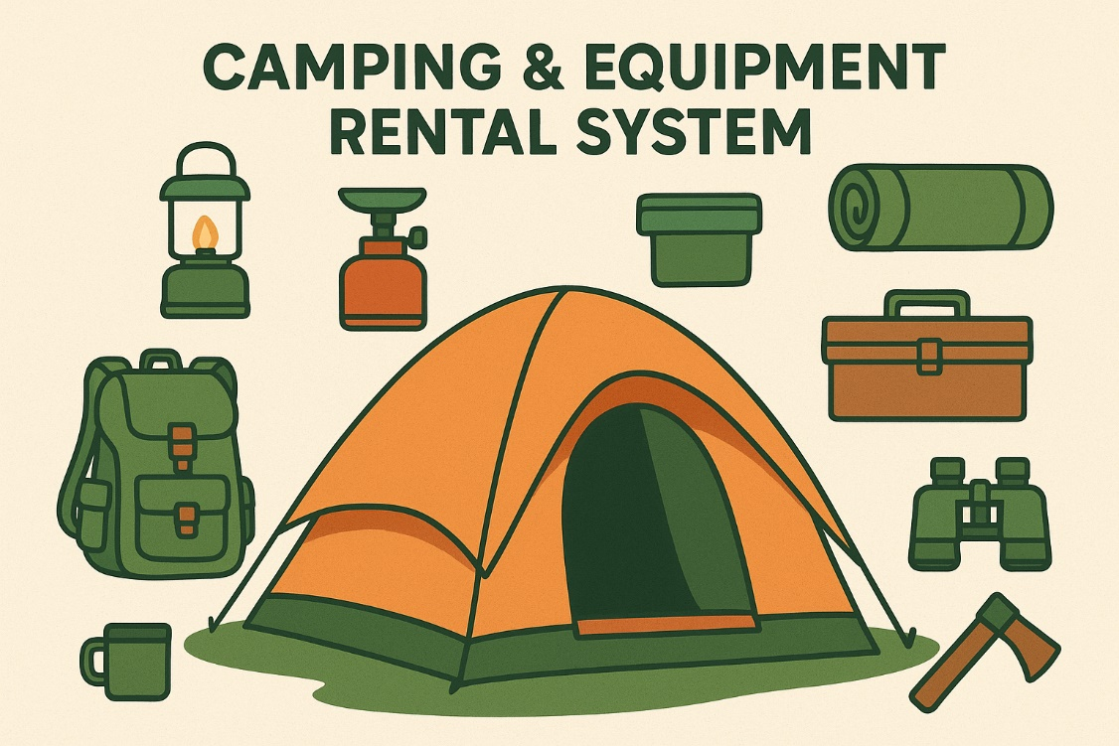

|  |  |  |
| --- | --- | --- |
| **Supervisor:** | Trương Thành Trung |  |
| **Class:** | T3.2308.A0 |
| **Group:** | 4 |
| **Serial No.** | **Student Name** | **Student ID** |
| 1 | Trần Phương Nam | Student |
| 2 | Trần Minh Nhật | Student |
| 3  4  5 | Phạm Hải Đăng  Hiếu  Dũng | Student1344667  Student1273504  Student |

Design plan: **Job board Management System** Document Name: **Review 1+2+3** Project group: 01

**TABLE OF CONTENT**

ACKNOWLEDGEMENT 4

INTRODUCTION 4

REVIEW 1 5

* 1. PROBLEM DEFINITION 5

FROM THE VIEW POINT OF THE CUSTOMERS 5

FROM THE VIEW POINT OF THE STAFF 5

FROM THE VIEW POINT OF THE WEBSITES’SADMINISTRATOR 6

* + 1. THE REQUIREMENTS OF THE PROJECT 6
    2. CURRENT STATE OF THE PROBLEM, AND SOLUTION 7

Current State of the Problem 7

Proposed Solution 7

* 1. CUSTOMER'S REQUIREMENTS SPECIFICATIONS (CRS) 9
     1. REQUIRE FUNCTION 9
     2. NON-FUNCTIONAL REQUIREMENTS 10
     3. DATA PROCESSING PROCESSES 11
     4. ALGORITHMS 12
        + Search 12
        + Sort 13
        + Machine learning 14
     5. HARDWARE/ SOFTWARE REQUIREMENTS 14

HARDWARE 14

SOFTWARE 15

TECHNOLOGY 15

* + 1. LIMITS OF THE PROJECT 16
  1. FUNCTION DIAGRAM 18
  2. TASK SHEET REVIEW 1 19

REVIEW 2 20

* 1. ARCHITECTURE AND DESIGN OF THE EPROJECT 20
  2. USECASE AND SEQUENCE DIAGRAM 22
     1. USECASE GENERAL 22
     2. USECASE DETAILS 24

Use Case List 25

Employer 27

Controller 36

UnRegister Candidate 46

* + 1. SEQUENCE DIAGRAM 56
  1. ENTITY RELATIONSHIP DIAGRAM (ERD) 75
     1. ERD General 75



Effective Date: **01/07/2023** Approved by: **Trần Phước Sinh** Page: **2**

Design plan: **Job board Management System** Document Name: **Review 1+2+3** Project group: 01

* + 1. ERD Details 76
  1. CLASS DIAGRAM 80
  2. TASK SHEET REVIEW 2 82

REVIEW 3 84

* 1. INSTALL DATABASE PHYSICAL 84

Create database and table 84

job 84

reasonstojoin 84

jobsdescriptions 85

skillsexperiences 85

whyyouloveworkinghere 85

employer 85

skill 86

jobskill 86

jobmonitor 86

review 89

candidate 89

answer 90

question 90

test 90

resumetemplate 90

resumepdf 91

Create relationship between tables 91

DATABASE TABLE & RELATIONSHIP DESIGN 95

* 1. SITE MAP 96
  2. CONSTRUCTOR PROJECT DIRECTORY 97
* Back end 97
* Frond end 100
  1. GUI DESIGN 102
     1. DESIGN INTERFACE (FIGMA) 102

WEB 102

For Candidate 102

Search job 102

View job details 104

Comments 104

Create CV 105

predict salary 106

Sign in 107

sign up 108

Test 109



Effective Date: **01/07/2023** Approved by: **Trần Phước Sinh** Page: **3**

Design plan: **Job board Management System** Document Name: **Review 1+2+3** Project group: 01

For Employer 110

Home 110

Post new job 110

update posted job 111

List posted job 111

create account 112

For Controller 113

Home 113

Manage controller manage staff, customer 113

Monitor behavior 114

review & approve job 116

MOBILE 117

menubar 117

Home 118

All job lists 119

login 120

sign up 121

profile 122

employer 123

login 124

sign up new employer 125

job details 126

job apply 127

All company lists 128

Company details 129

company review 130

upload/create CV 131

create new CV 132

favorite list 133

take the test 134

List Job Posted 135

Review CV 136

CV details 137

Download CV 139

Update Employer Account 141

* + 1. DETAILED DESCRIPTION OF THE FUNCTION 145

AND INPUT/OUTPUT DATA ANALYSIS 145

Web 145

For candidate 145

Show jobs 145



Effective Date: **01/07/2023** Approved by: **Trần Phước Sinh** Page: **4**

Design plan: **Job board Management System** Document Name: **Review 1+2+3** Project group: 01

View job details 147

Comments 148

Create CV 150

predict salary 151

Sign in 152

sign up 153

Test 155

For Employer 156

Post new job 156

update posted job 157

For Controller 158

Manage controller manage employer, manage candidate 158

Monitor behavior 160

review & approve job 160

MOBILE 161

* + - 1. Home Page 161
      2. Login 162

Login Candidate 163

Login Employer 165

* + - 1. Sign Up 166

Sign Up Candidate 167

Sign Up Employer 169

* + - 1. Profile 171

1. Jobs Favorite List 174
2. Take The Test 176
3. Job Details 178
4. Job Apply 179
5. Company List 180
6. Company Details 181

3.4.4 DESCRIPTION OF DATA PROCESS, APPLIED ALGORITHM (IF ANY) 184

* 1. TASK SHEET REVIEW 3 187



Effective Date: **01/07/2023** Approved by: **Trần Phước Sinh** Page: **5**

### ACKNOWLEDGEMENT

We would like to take this opportunity to convey our deepest appreciation to all those who contributed to the completion of this project.

First and foremost, our sincere gratitude goes to our respected instructor, Mr. Trương Thành Trung, whose patient guidance and valuable insights continuously inspired us throughout the project. His encouragement not only strengthened our technical knowledge but also motivated us to face challenges with confidence.

We are also profoundly grateful to the project coordination team for granting us the chance to put theory into practice. This project has been a meaningful bridge between classroom learning and real-world application, and the experience gained will undoubtedly serve us well in our future professional paths.

We would also like to acknowledge the consistent support of the staff at our center, whose guidance and encouragement provided us with a positive environment to remain focused and committed throughout the project.

Lastly, we extend heartfelt thanks to our teammates and fellow classmates. Their enthusiasm, cooperation, and willingness to share ideas made this journey both productive and enjoyable. The collective effort and team spirit were the keys to overcoming obstacles and achieving our objectives.

### INTRODUCTION

In recent years, outdoor recreation and nature-based tourism have become increasingly popular as people seek healthier lifestyles, eco-friendly travel options, and alternatives to traditional accommodations. However, campers often face challenges such as limited access to campsite information, lack of availability tracking, and the inconvenience of bringing or purchasing their own equipment. This project addresses these issues by offering an all-in-one solution that combines campsite reservations with equipment rental in a single platform.

This project presents the development of a web-based application for campsite booking and outdoor equipment rental. The system is designed to provide users with a simple and reliable method to search for available camping locations, view details, and make reservations online. In addition, the platform integrates equipment rental services, allowing users to conveniently select and reserve camping gear such as tents, cooking sets, sleeping bags, and other essential items.

By bridging the gap between demand and convenience, the proposed system provides a practical response to today’s increasing interest in outdoor activities, making camping more accessible, organized, and enjoyable for a wide range of users.

* 1. **PROBLEM DEFINITION**

# REVIEW 1

In today’s fast-paced world, outdoor activities such as camping have become increasingly popular as people seek relaxation, adventure, and a closer connection with nature. However, the process of organizing a camping trip still presents several challenges. Campers often face difficulties in finding available campsites, comparing facilities, and ensuring proper reservations. In addition, many individuals—especially beginners—struggle with accessing the necessary equipment, which can be expensive to purchase and inconvenient to carry.

Traditional methods of campsite booking, such as phone calls or on-site reservations, are often inefficient, lack transparency, and provide limited options for users. Similarly, equipment rental services are usually scattered and not integrated with campsite bookings, leading to fragmented experiences for campers. These issues result in wasted time, increased costs, and reduced accessibility, which discourage many from fully enjoying outdoor adventures.

To address these challenges, we propose the development of a **Camping and Equipment Rental System**. This web-based application is designed to provide a unified platform where users can easily search for and reserve camping spots while also renting essential equipment in a convenient and transparent manner. The system not only simplifies the booking process for customers but also supports campsite managers and rental providers by streamlining operations and improving communication with clients.

By bridging the gap between demand and accessibility, the Camping and Equipment Rental System aims to modernize the camping experience, making it more efficient, affordable, and enjoyable for all users.

###### THE REQUIREMENTS OF THE PROJECT

* User Registration and Profiles:
  + Allow customers and staff to register and create user accounts.
  + Support login via email/password as well as social login (Google, Facebook).
  + Enable customers to manage their personal profiles, booking history, and feedback.
* Campsite and Service Booking:
  + Allow customers to browse and filter available campsites or glamping options based on location, availability, and service details.
  + Provide an option to add services and equipment rentals when booking a campsite.
  + Enable customers to review booking details, add items to a cart, and complete online payment through VNPAY, ….
  + Allow users to manage and track their booking history.
* Equipment and Service Management:
  + Enable administrators to create and manage a catalog of rental equipment, including details such as description, pricing, and stock availability.
  + Allow the creation of service packages (e.g., camping gear combos, food service combos) with predefined pricing and quantities tailored to group sizes.
  + Support updating, editing, and removing services or equipment as needed.
* Analytics and Reporting:
  + Generate dashboards with statistics on new users, bookings, revenue (daily, weekly, monthly, yearly), and service usage.
  + Provide detailed reports for business performance monitoring and decision-making.
* Security and Data Privacy:
  + Implement secure authentication, encrypted transactions, and data protection mechanisms.
  + Ensure that personal information and booking data are stored and managed safely.
* User Experience and Accessibility:
  + Provide a responsive design accessible across desktop and mobile devices.
  + Ensure intuitive navigation, clear service categorization, and a user-friendly booking flow.
  + Continuously improve usability based on customer feedback and testing.

Design plan: **Job board Management System** Document Name: **Review 1+2+3** Project group: 01

###### CURRENT STATE OF THE PROBLEM, AND SOLUTION

Current State of the Problem:

In today’s context, camping enthusiasts often face multiple challenges when planning a trip. Users usually have to find camping spots manually, contact campsite managers, and prepare equipment, gear, and food on their own. This process is time-consuming, inconvenient, and may result in missing essential items (such as tents, stoves, or food).

On the other hand, campsite managers and equipment rental providers struggle with promoting their services, handling bookings, and managing rental equipment. The lack of a centralized system creates inefficiencies, delays, and an unsatisfactory experience for both customers and service providers.

Proposed Solution:

The **Camping & Equipment Rental System** is designed to address these challenges by offering an online platform that connects customers with campsite managers and rental services.

* + - * **Easy Campsite Booking:** Users can book camping spots directly through the system, selecting location, time, and additional services. This reduces the complexity of manual communication.
      * **Equipment and Food Rental:** The system allows customers to rent tents, stoves, cooking tools, and order food in advance. This ensures that they are fully prepared for their trips.
      * **Comprehensive Service Management:** Campsite managers can post detailed information about their sites, rental equipment, and available food menus. The system also supports equipment inventory management, booking schedules, and order tracking.
      * **User Profiles & Booking History:** Customers can create profiles to store their personal details, past bookings, rented items, and food orders. This provides a personalized and more convenient user experience.
      * **Communication & Order Tracking:** The system facilitates smooth communication between customers and providers. Users can track the status of their bookings, rentals, and food orders in real time.
      * **Smart Recommendations:** Based on customer profiles and booking history, the system can suggest suitable packages (e.g., tent + stove + BBQ food combo).
      * **Analytics & Insights:** Service providers gain access to reports on customer demand, popular rental items, and revenue trends. These insights help improve business strategies.
      * **Monetization Options:** The platform can generate revenue through subscription plans, commission fees for each booking, or premium features for service providers.

By implementing this system, customers benefit from a seamless booking experience, complete camping preparation, and enhanced convenience. Meanwhile, campsite managers and rental providers can streamline their operations, expand customer reach, and improve service efficiency.



Effective Date: **01/07/2023** Approved by: **Trần Phước Sinh** Page

### CUSTOMER'S REQUIREMENTS SPECIFICATIONS (CRS)

The project is to design a car **Job board Management System**.

###### REQUIRE FUNCTION

* + - * + There are 2 main types of actors in this application:
        + **Customer** – individuals who want to book a campsite and rent equipment.

**Unregistered Customer**:

View available camping spots and services.

View details of campsites, equipment, and packages.

Search and filter services by location, type, or price.

Sign up for an account.

**Registered Customer**:

Sign in and manage profile.

Book campsites and rent equipment.

Add services/equipment to cart and checkout via online payment (VNPAY, …).

View booking history.

Leave reviews and feedback.

Read blogs and articles related to camping.

* + - * + **Admin & Staff** – managers responsible for maintaining the system.

Manage campsite and equipment inventory (CRUD operations).

Manage service combos and packages (create, update, pricing).

Manage customer bookings, approvals, check-in, and check-out.

Manage staff scheduling for customer support.

Generate invoices and send confirmations via email.

Manage blog posts and customer feedback.

Monitor reports and analytics (user activity, bookings, revenue).

Ensure system security and smooth operations.

###### NON-FUNCTIONAL REQUIREMENTS

* + - * + **Usability**: The system must provide an intuitive and responsive interface across web and mobile.
        + **Performance**: The platform should support a large number of concurrent users without delays.
        + **Availability**: The service should be accessible 24/7 with minimal downtime.
        + **Security**: Strong authentication and encrypted transactions must be implemented.
        + **Scalability**: The system should handle future growth in users, bookings, and services.
        + **Compatibility**: The website should run smoothly on major browsers and devices.

###### HARDWARE/ SOFTWARE REQUIREMENTS

HARDWARE

|  |  |
| --- | --- |
| **Component** | **Specification** |
| **Web Server** | Processor: Intel Core i7 or higher  RAM: 16 GB or more  Storage: 256 GB SSD or higher  Internet: Stable broadband/ADSL connection |
| **Client** | Processor: Intel Core i5 or higher  RAM: 4–8 GB  Display: Super VGA (1024x768) or higher resolution  Internet: Broadband or mobile data |

SOFTWARE

Web Server

|  |  |
| --- | --- |
| **Operation System** | Window 7 or later. |
| **Browser** | Google Chrome version 35. |
| **Database** | SQL SERVER |
| **Software** | Internet Information Service |
| * VISUAL STUDIO 2022 * VISUAL STUDIO CODE * ECLIPSE IDE * MICROSOFT SQL SERVER MANAGEMENT STUDIO * GOOGLE CHROME * FIGMA * ChatGPT |

TECHNOLOGY

|  |  |
| --- | --- |
| **Type** | **Technologies Used** |
| **Languages** | Java (Spring Boot), JavaScript, JSX, HTML, CSS |
| **Frameworks** | Spring Boot (Backend), NextJS (Frontend) |
| **Database** | MySQL |
| **Collaboration** | GitHub (Version control), ChatGPT |

###### LIMITS OF THE PROJECT

* + - * Limited to camping-related services (not designed for hotels or other industries).
      * System success depends on customer and campsite owner adoption.
      * Equipment information relies on accurate admin input.
      * Initial release may not cover advanced AI recommendations.

### FUNCTION DIAGRAM

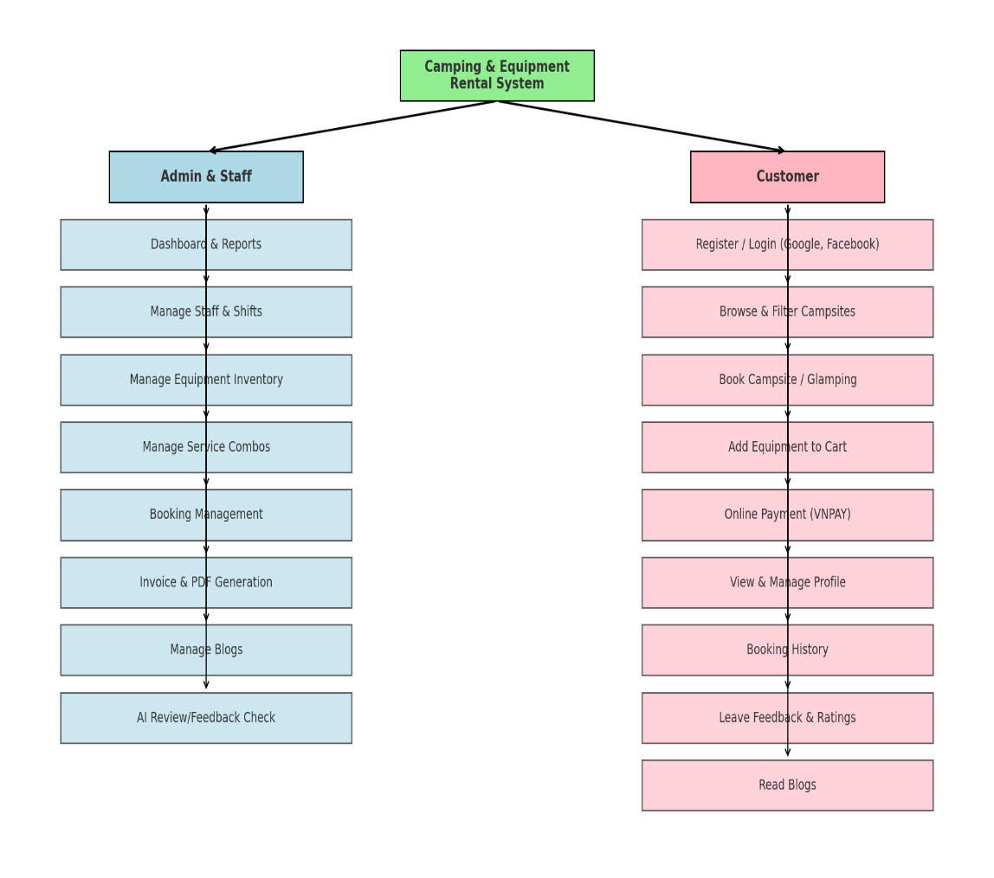

### TASK SHEET REVIEW 1

|  |  |  |  |  |  |  |  |  |  |  |  |
| --- | --- | --- | --- | --- | --- | --- | --- | --- | --- | --- | --- |
| **Project Ref.No** | | | **Project Title** | **Activity plan prepared by** | | **Date of preparation of Activity plan** | | | | | |
| **#** | **Task** | | **Start date** | **End date** | **Actual days** | **Member's name** | | **Status** |
| 1 | Acknowledgement | |  |  | |  |  | 2 |  | | Done |
| 2 | Introduction | |  |  | 2 |  | | Done |
| 3 | Problem definition | |  |  | 2 |  | | Done |
| 4 | The requirements of the project | |  |  | 2 |  | | Done |
| 5 | Current state of the problem, and solution | |  |  | 2 |  | | Done |
| 6 | Customer requirement specification (CSR) | |  |  | 2 |  | | Done |
| 7 | Non-functional requirement | |  |  | 2 |  | | Done |
| 8 | Data processing processes | |  |  | 2 |  | | Done |
| 9 | Algorithms | |  |  | 2 |  | | Done |
| 10 | Hardware/software requirement | |  |  | 2 |  | | Done |
| 11 | Limits of the project | |  |  | 2 |  | | Done |
| 12 | Function diagram | |  |  | 2 |  | | Done |
| 13 | Task Sheet review 1 | |  |  | 2 |  | | Done |
| **Signature of instructor** | | | **Signature of Team Leader** | | | | |
|  | | |  | | | | |
| **Mr.** | | | **Mr.** | | | | |

# REVIEW 2

### ARCHITECTURE AND DESIGN OF THE EPROJECT

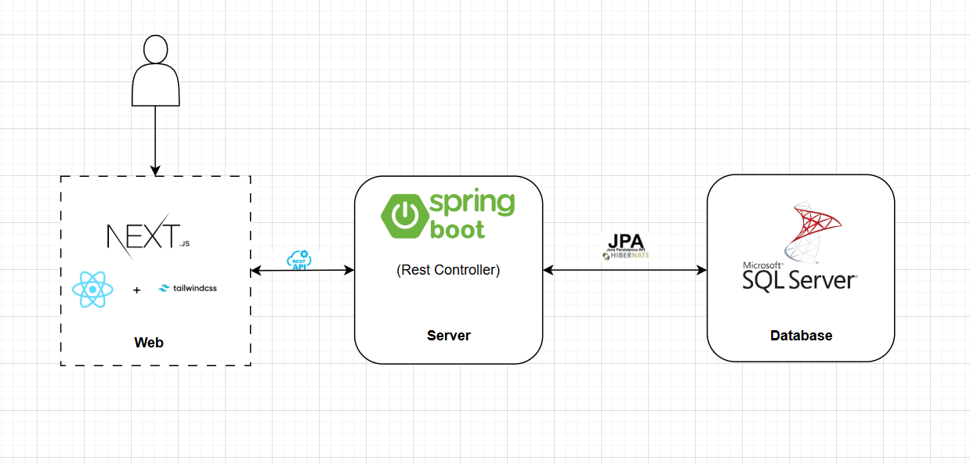

### USECASE AND SEQUENCE DIAGRAM

###### USECASE GENERAL

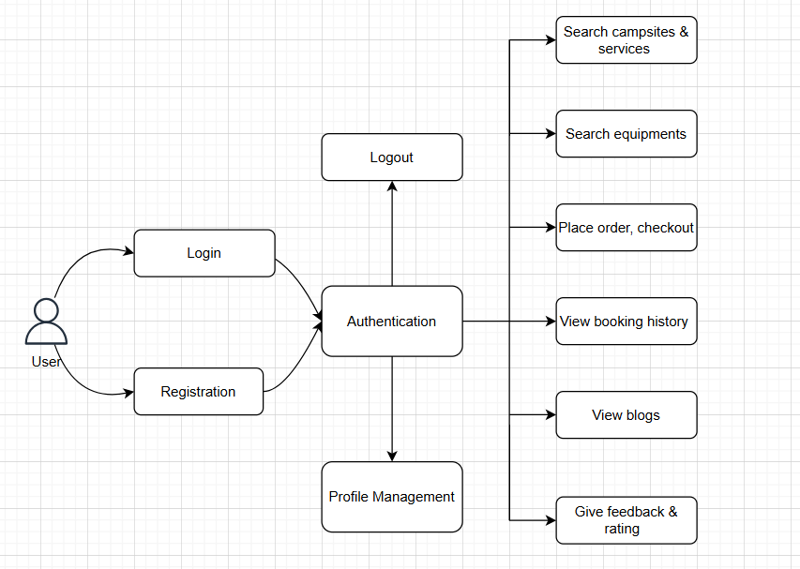

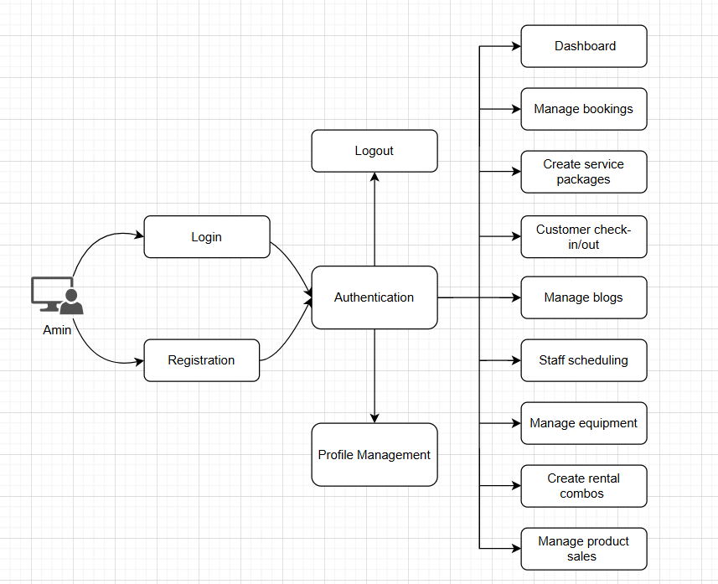

### TASK SHEET REVIEW 2

|  |  |  |  |  |  |  |  |  |
| --- | --- | --- | --- | --- | --- | --- | --- | --- |
| **Project Ref.No** | | **Project Title** | **Activity plan prepared by** | **Date of preparation of Activity plan** | | | | |
| **#** | **Task** | **Start date** | **End date** | **Actual days** | **Member's name** | **Status** |
| 1 | Architecture and design |  |  |  |  | 5 |  | Done |
| 2 | Use case general |  |  | 5 |  | Done |
| 3 | Use case details 50% |  |  | 6 |  | Done |
| 4 | Use case details 50% |  |  | 6 |  | Done |
| 5 | Sequence diagram 50% |  |  | 6 |  | Done |
| 6 | Sequence diagram 50% |  |  | 6 |  | Done |
| 7 | Entity Relationship Diagram (ERD) general |  |  | 5 |  | Done |
| 8 | ERD details 50% |  |  | 6 |  | Done |
| 9 | ERD details 50% |  |  | 6 |  | Done |
| 10 | Class Diagram |  |  | 5 |  | Done |
| 11 | Task Sheet review 2 |  |  | 6 |  | Done |

# REVIEW 3

### INSTALL DATABASE PHYSICAL

Download SQL Server:

* Visit the Microsoft website or the SQL Server download center to get the installation package for the SQL Server version you want to install. Make sure to download the appropriate edition (Express, Standard, or Enterprise) based on your needs.

Run the Installer:

* Locate the downloaded installer and run it as an administrator.

Create database and table

###### DATABASE TABLE & RELATIONSHIP DESIGN

### 1.2 SITE MAP

**2. GUI Design**

**  
 2.1 LOGIN PAGE**

**ACCOUNT LOGIN :**

**+ROLE (ADMIN) email: admin@gmail.com password:123456  
 +ROLE (STAFF) email: staff@gmail.com password:123456  
 +ROLE(CUSTOMER): YOU CAN LOG IN WITH YOUR ACCOUNT BECAUSE WHEN CUSTOMERS LOGIN WITH YOUR EMAIL, THEY WILL RECEIVE AN EMAIL WHEN THEY PLACE AN ORDER.**

**2.2 HOME PAGE**

2.4 STAFF DASHBOARD

2.5 STAFF DASHBOARD FOOD MANAGEMENT

* 1. STAFF DASHBOARD CUSTOMER MANAGEMENT ORDERING ADDITIONAL MEALS

**2.7 STAFF BLOG**

2.8 STAFF MANAGE ASSESSMENTS

2.9 SEE REVIEWS BY SERVICES

3.0 AI CONSULTING SERVICES

### 1.3 FlowTask WebSite

#### ServiceẢnh có chứa văn bản, ảnh chụp màn hình, Trang web, phần mềm Nội dung do AI tạo ra có thể không chính xác.

#### ServiceDetail

#### Ảnh có chứa văn bản, ảnh chụp màn hình, phần mềm, Trang web Nội dung do AI tạo ra có thể không chính xác.Combo

#### Ảnh có chứa văn bản, ảnh chụp màn hình, Trang web, Website Nội dung do AI tạo ra có thể không chính xác.ComboDetail

#### Ảnh có chứa văn bản, ảnh chụp màn hình, cây cối, Trang web Nội dung do AI tạo ra có thể không chính xác.Cart

#### Ảnh có chứa văn bản, ảnh chụp màn hình, Trang web, Website Nội dung do AI tạo ra có thể không chính xác.Checkout

#### Ảnh có chứa văn bản, ảnh chụp màn hình, phần mềm, số Nội dung do AI tạo ra có thể không chính xác.PaymentẢnh có chứa văn bản, ảnh chụp màn hình, phần mềm, Biểu tượng máy tính Nội dung do AI tạo ra có thể không chính xác.

#### Payment SuccessẢnh có chứa văn bản, ảnh chụp màn hình, Trang web, Website Nội dung do AI tạo ra có thể không chính xác.

#### Payment FailẢnh có chứa văn bản, ảnh chụp màn hình, Phông chữ Nội dung do AI tạo ra có thể không chính xác.

#### History BookingẢnh có chứa văn bản, ảnh chụp màn hình, Phông chữ Nội dung do AI tạo ra có thể không chính xác.

#### Admin booking managementẢnh có chứa văn bản, ảnh chụp màn hình Nội dung do AI tạo ra có thể không chính xác.

#### Admin Staff ManagementẢnh có chứa văn bản, ảnh chụp màn hình, phần mềm, số Nội dung do AI tạo ra có thể không chính xác.

#### Admin assigns employees to shiftsẢnh có chứa văn bản, ảnh chụp màn hình, Phông chữ Nội dung do AI tạo ra có thể không chính xác.

#### Admin assigns staff to bookingẢnh có chứa văn bản, ảnh chụp màn hình, phần mềm, số Nội dung do AI tạo ra có thể không chính xác.

#### Booking staffẢnh có chứa văn bản, ảnh chụp màn hình, số, Phông chữ Nội dung do AI tạo ra có thể không chính xác.

#### Schedule staffẢnh có chứa văn bản, ảnh chụp màn hình, Phông chữ, hàng Nội dung do AI tạo ra có thể không chính xác.Ảnh có chứa văn bản, ảnh chụp màn hình, hàng Nội dung do AI tạo ra có thể không chính xác.

#### Admin service managementẢnh có chứa văn bản, ảnh chụp màn hình, số, phần mềm Nội dung do AI tạo ra có thể không chính xác.

#### Admin combo managementẢnh có chứa văn bản, ảnh chụp màn hình, phần mềm, số Nội dung do AI tạo ra có thể không chính xác.

### FlowTask Mobile

#### Login MobileẢnh có chứa văn bản, ảnh chụp màn hình, phần mềm Nội dung do AI tạo ra có thể không chính xác.

#### HomePageẢnh có chứa văn bản, ảnh chụp màn hình, phần mềm Nội dung do AI tạo ra có thể không chính xác.

#### Service page mobileẢnh có chứa văn bản, ảnh chụp màn hình Nội dung do AI tạo ra có thể không chính xác.

#### Combo page mobileẢnh có chứa văn bản, ảnh chụp màn hình, cây cối Nội dung do AI tạo ra có thể không chính xác.

#### ServiceDetail page mobileẢnh có chứa văn bản, ảnh chụp màn hình Nội dung do AI tạo ra có thể không chính xác.

#### ComboDetail page mobileẢnh có chứa văn bản, ảnh chụp màn hình, cây cối Nội dung do AI tạo ra có thể không chính xác.

#### Cart Page MobileẢnh có chứa văn bản, ảnh chụp màn hình, phần mềm, Phông chữ Nội dung do AI tạo ra có thể không chính xác.

#### Confirm cart mobileẢnh có chứa văn bản, ảnh chụp màn hình, phần mềm, Phông chữ Nội dung do AI tạo ra có thể không chính xác.

#### Checkout Vnpay mobileẢnh có chứa văn bản, ảnh chụp màn hình, phần mềm, Biểu tượng máy tính Nội dung do AI tạo ra có thể không chính xác.

#### Payment Success mobilẢnh có chứa văn bản, ảnh chụp màn hình, Phông chữ, thiết kế Nội dung do AI tạo ra có thể không chính xác.

#### Payment Failure mobileẢnh có chứa văn bản, ảnh chụp màn hình, Phông chữ, biểu tượng Nội dung do AI tạo ra có thể không chính xác.